# Jack's Italian Adventures: Part One

*I started on this post over 2 weeks ago, but with so much going on surrounding Coy's rapid decline and subsequent passing, I set all of this aside for a time. Now it finally feels like the right time to finish things up and to share some of the fun we had in Italy with Jacob, Hannah, and Jack for 12 days.

Jack is so great! He is a dynamic mixture of sweet and snuggly and loves to have multiple books read to him, contrasting with his zest for having a job to do - especially in the kitchen, contrasting with his spunky/crazy side where he loves to chuck balls and other toys from the upstairs balcony and watch them hit the couch downstairs and then ricochet around the living room. He is happy to play with his toy fire truck while riding in the stroller to the grocery store and back, but he is just as happy running wild and free to chase bunnies all over the park. He loves seafood, including fish and shrimp, but hates bananas. He is extremely smart, and is learning new words every day. I have picked up on several words that are easily recognizable. For example, he can say: bye-bye, hi, rice, bapple (apple), wa-wa (water), cheese, all the animal sounds, peeee (please), da-doo (thank you), and a few other words that I can't think of right now.

Monday, May 1st:

Jack really does love to sleep. He is very good at that. From Sunday night into Monday morning, he slept for about 14 hours straight . . .

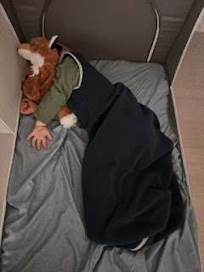

Yes, that was much longer than usual, but then he did just travel across the Atlantic Ocean and jump ahead by a few time zones as he flew from Washington DC to Venice . . .

Hannah woke up not feeling too well that morning, so she also appreciated being able to sleep in for a while. She had a sore throat and couldn't go to sleep for a long time the night before because of a runny nose. I made her some tea ("Throat Coat" brand) and that seemed to help. We went for a 10 minute walk to the InterSpar to pick up a couple items for dinner that night, and to let Jacob and Hannah take a peek into an Italian grocery store for the first time.

The Lidl across the street from our house was closed for the day because it was a national holiday - Labor Day. But I got brave and called the InterSpar to see if they were truly open - Google is awesome, but not always accurate about these things. I was able to say: "Buon giorno. Siete aperti oggi?" (Good morning. Are you open today?) The response was, "Si, si. _______ due." The gist of what I heard and understood basically meant, yes we are open, but only until two. Great! I thanked her and we both said, "Arrivederci."

Jacob was intrigued by some fancy bologna, so we waited with our numbered ticket until it was our turn. I conveyed that I needed "Due fetta" (two slices) of the giant slab of bologna, which they promptly sliced and then packaged it up nice and neatly. Jack, meanwhile, was just singing and happy as could be with his fire truck and bare feet in the stroller. :)

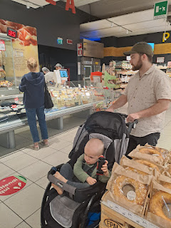

The bologna that we got was on the bottom row of the photo below: 5th from the right, and also 5th from the left. It had bits of pistachios and peppercorns in it, and it was surprisingly good!

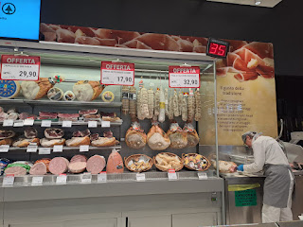

While Jack was napping later in the afternoon, we heard a loud group outside. I looked out the kitchen window to see a large crowd across the roundabout in what appeared to be a demonstration of some sort. They had a loudspeaker and a lady was yelling something over and over into it. They had signs and flags and maybe 50-75 people in their group.

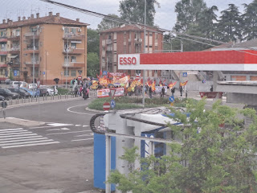

Jacob looked up some of the words that were on their banners and we learned that it was a labor union group, who were advocating for: no more war, no more military in Vicenza, higher wages, and no more sending weapons to Ukraine. I wasn't sure what to make of it all, because I don't have a deep enough understanding of both sides of the issues. They were out there for at least 30 minutes, though, letting the whole neighborhood know what they were advocating for.

Once Jack's nap was done, we knew we had limited time before the rains came, so we hurried across town to a new park, one that had been recommended by a friend in our ward here: Parco Querini here in Vicenza. Also known as "The Bunny Park". Scott was home by then, and was able to join us. Yay!

As we drove into the parking area, there were already bunnies hopping along the side of the road, ha ha. We had no idea just how many bunnies we were about to see . . .

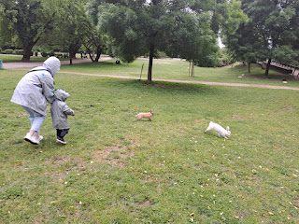

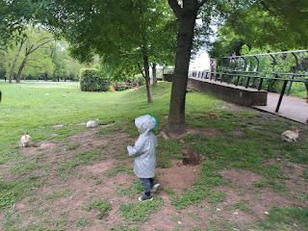

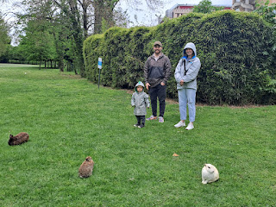

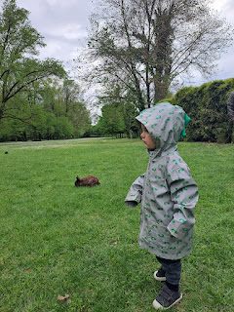

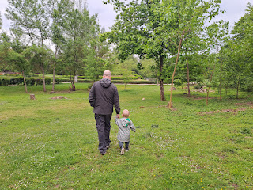

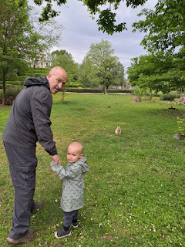

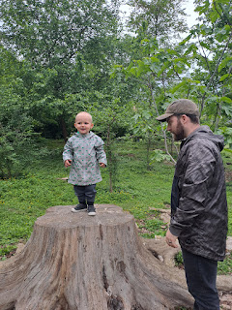

Video #1: Bunny stretching out to rest. (16 seconds)

https://photos.app.goo.gl/P4U1ih9AzcrAw2EJ7

As we walked around the park, we noticed even more creatures and critters in the water surrounding a monument up on a little hill.

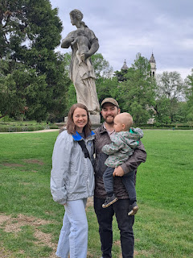

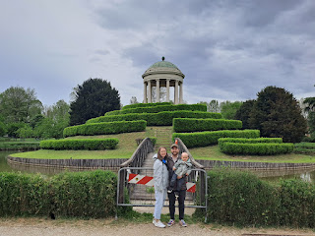

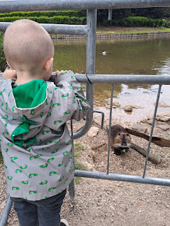

Video #2: An interesting creature, called a Nutria. Similar to a muskrat, but much larger. (51 seconds)

https://photos.app.goo.gl/G6g5M2Tkmccx4Zhe8

Per the internet: An adult nutria is about 1/3 the size of an adult beaver and over 5 times the size of a muskrat. It is also known as the coypu, and is a large, herbivorous, semiaquatic rodent.

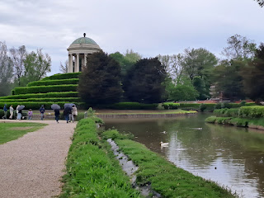

We stood watching all the turtles, nutrias, ducks and geese, for a long time before moving on. It was a little bit sprinkly outside, but we all had rain jackets on so it didn't bother us. In order to convince Jack to leave the animals, Jake and Hannah had to suggest doing 1-2-3 while holding his hands and swinging him up high on "3".

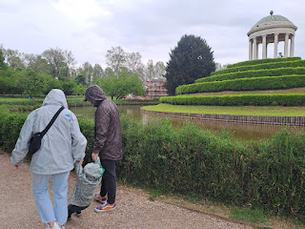

Then Scott and Jake took a shift doing the same thing.

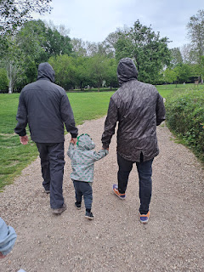

It was hilarious to watch from behind, because Jack was clearly wanting the "swing" part, but not so much the walking part. LOL

Video of Jack: (11 seconds)

https://photos.app.goo.gl/1VK5F2BZSiBmrM4S8

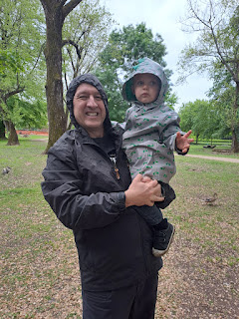

As we got closer to the exit, we came across a large grouping of roosters on the ground, with the hens nestled up in the higher branches of the shrubs. You might never even see the hens, unless you came up really close and looked up high, because they were embedded deep within the shrubby branches. It seemed to be a very protected and sheltered place for them.

Video of Jack meeting up with a rooster: (20 seconds)

https://photos.app.goo.gl/NNmz17ryocZxs4qp6

Peeking in at the hens . . .

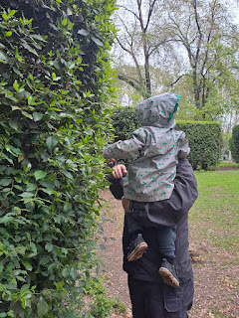

Tuesday, May 2nd:

Good morning Jack! He loved going upstairs to play several times a day.

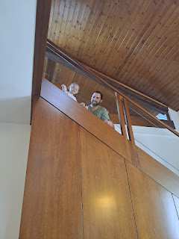

I took them to the Palladio Mall, since it was another rainy day. We let him play in the children's play area for a while before doing a little shopping in Emisfero (our favorite grocery store).

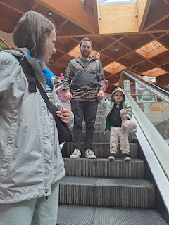

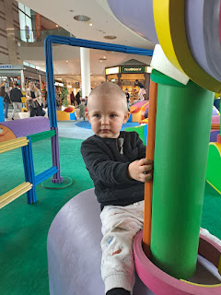

Video of Jack riding the carousel and giggling with joy: (14 seconds)

https://photos.app.goo.gl/8DDukWG19PWjvi62A

We rented a race car shopping cart for one euro and Jack was happy to go wherever we drove him.

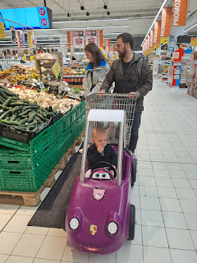

As long as he had a snack to eat, too . . .

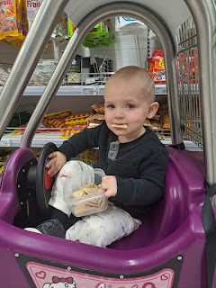

A little later, we went for a walk around downtown Vicenza. He wanted to get out of his stroller and "walk", but that quickly turned into a sprint through the piazza, ha ha. We ran into Jon Carlo for the first time, as we tried to keep up with Jack. Jon Carlo is such a friendly man!! He spoke very good English and was really enjoying a chat with Jack. We learned that he owns one of the gelaterias near the piazza.

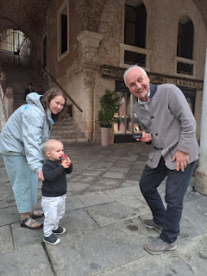

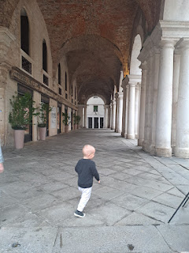

We did get a pretty good photo shoot of Jack before he ran off again . . .

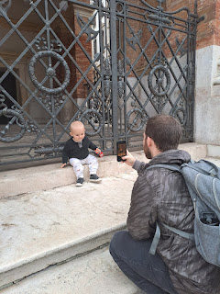

Soon enough, it was time to go back into the stroller.

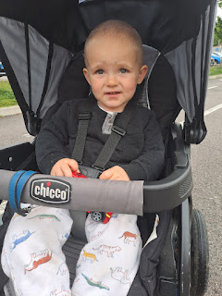

We were hoping to visit the Chiesa della Santa Corona, but it was closed for some reason. Monday was Italian Labor Day, but this was Tuesday . . . so . . . ??? We found another nearby church that was open and we spent a few minutes appreciating the beauty inside.

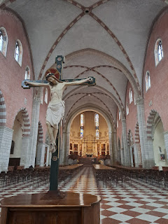

After we rode the bus back across town, we walked past our house to order pizza at my favorite place down the street, Pizza Express da Angelo. They are quick and it only takes 10 minutes, even for multiple pizzas. While we waited, we played at the park across the street. Jacob has started referring to it as the "Pizza Park".

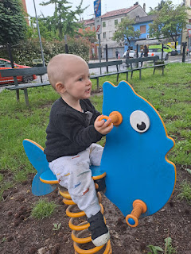

After dinner it was bathtime and bedtime. :)

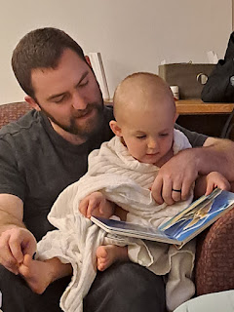

Wednesday, May 3rd:

We took the entire day to go visit Venice and it was wonderful! We bought train tickets to go from Vicenza to the Santa Lucia Station in Venice and it only took 48 minutes total. First, we rode the bus from our house over to the train station, and then we were off.

I loved listening to these ladies chatting away so animatedly on the short bus ride. :)

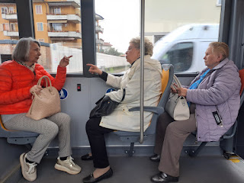

Waiting for our train . . .

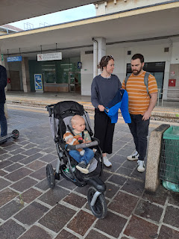

Off we go . . .

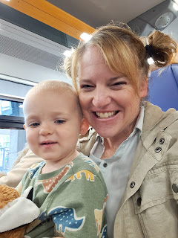

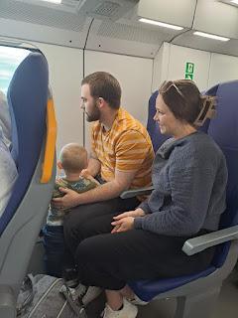

Straight out of the train station, we were standing on the edge of the Grand Canal.

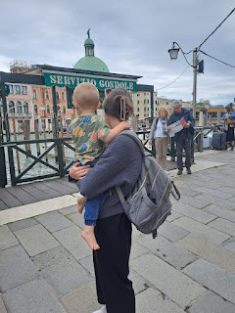

In the interest of time, I'm just going to let you take a walk with me through the streets, alleys, and bridges over too many canals to count. Enjoy!

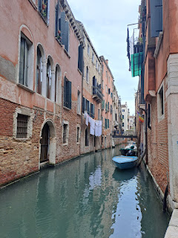

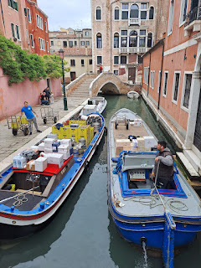

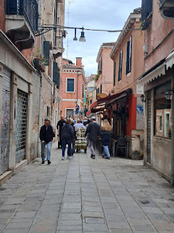

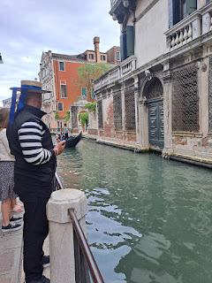

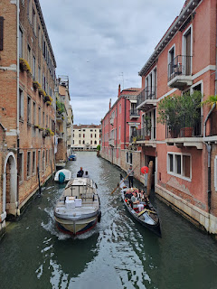

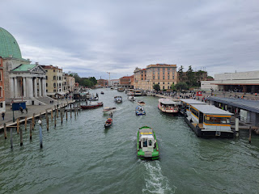

When I saw all the varieties of cannolis in the storefront windows, I told myself that I would buy one somewhere before I left the Lagoon. Sadly, it didn't happen . . . but I did get some gelato at the last minute before we hopped on the train home.

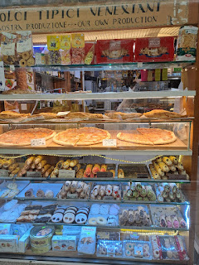

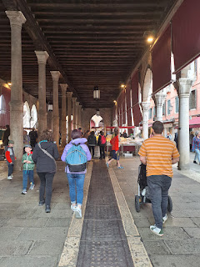

I've never seen the fish market in Venice before, but on this particular day, everything was on display in all its fishy splendor.

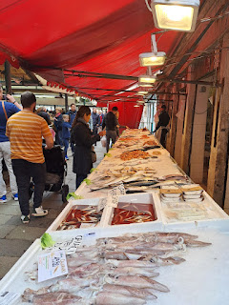

Video of the fish market as we passed through: (27 seconds)

https://photos.app.goo.gl/UQoSng16syEeJAGv8

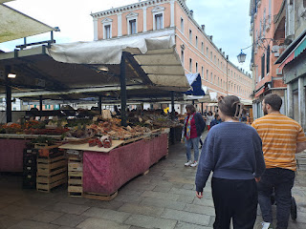

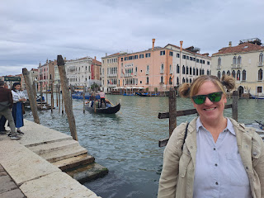

Video of a man playing his violin as we walked by: (11 seconds)

https://photos.app.goo.gl/i1ie6W7vjubYGCAX6

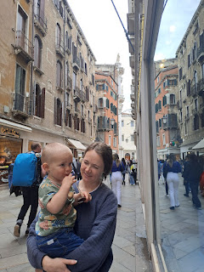

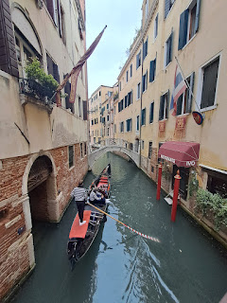

This guy was cleaning the front window of a fancy men's suit store, while wearing a fancy men's suit.

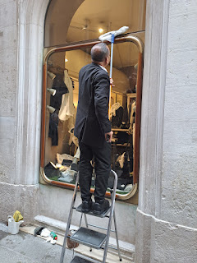

We walked all the way across Venice from the train station to St. Mark's Square, which took about 45 minutes through all the alleys and over the canals.

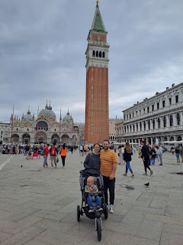

Video of Jack's perspective in St. Mark's Square: (27 seconds)

https://photos.app.goo.gl/eURXtUaka9ZUpJmRA

Video of a more complete perspective in the same square: (24 seconds)

https://photos.app.goo.gl/5twm3Q5ANyst2rkYA

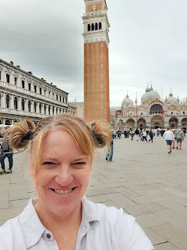

Video #1 of some worker guys on the docks: (17 seconds)

https://photos.app.goo.gl/GjxvYcpP8U2EJDfU6

Video #2 of the same worker guys: (17 seconds)

https://photos.app.goo.gl/nbrqK7q4YH8GdEUi8

I think what they were doing was plucking up the giant wooden posts to then trim one end and make it pointy again (the one end was starting to rot in the water), then flip it over and slam it back into the silty water with the newly cut pointy tip.

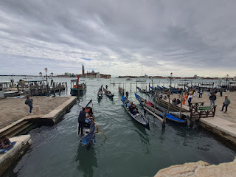

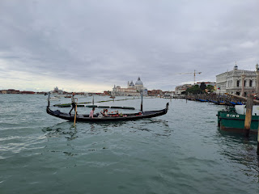

We got brave and decided to try to walk around the entire "island" of Venice. (I read somewhere recently that it's an "island" made up of about 118 islands, separated by all the canals.) As we walked down the wide promenade, along the southern edge to the east, we came to a section of gardens. It was much quieter out on this southeastern tip, with only a few people walking around, compared to hundreds upon hundreds of people earlier.

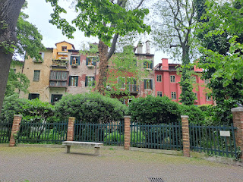

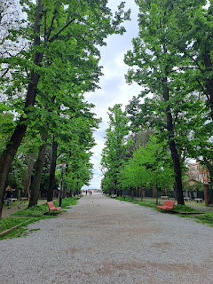

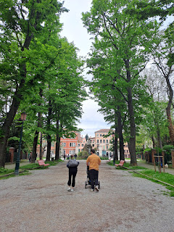

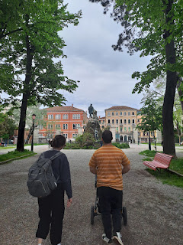

Jack finally drifted off to sleep around this time, much to the relief of his parents.

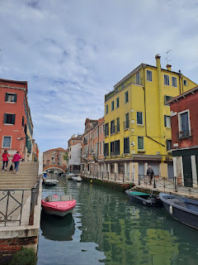

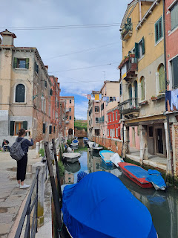

I got permission to take a photo of this man, who, along with his wife, were painting with watercolors in a quiet little nook near a dead end.

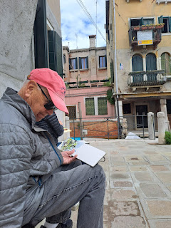

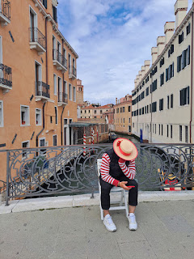

I filled my water bottle with fresh water from this well . . . it was nice and cold.

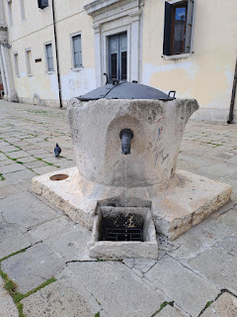

We all helped get Jack and his stroller up and over all the bridges during the day, but Jake decided to take matters into his own hands at one point. He power-lifted Jack AND the stroller AND all the gear in the large pocket underneath all by himself!!!

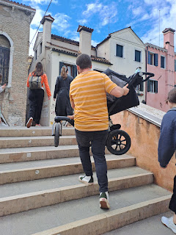

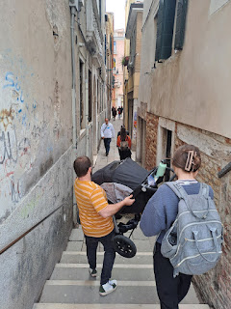

We found another huge Catholic Basilica to visit . . .

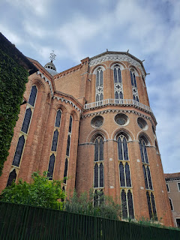

This was the view coming around to the front entrance.

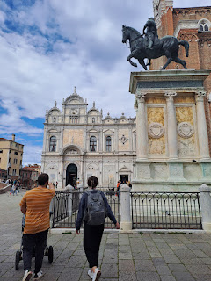

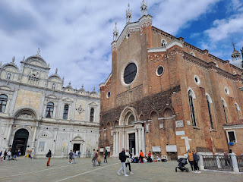

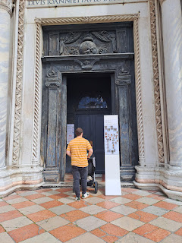

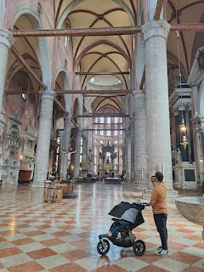

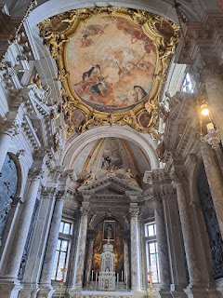

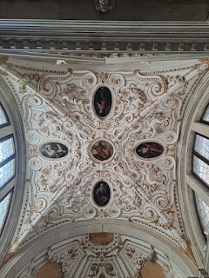

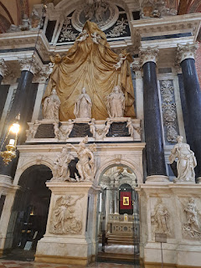

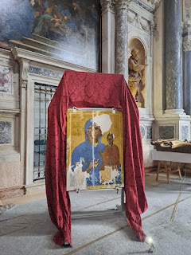

Explanation for the painting above is in the photo below.

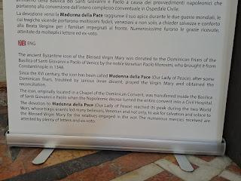

An epitaph of some kind on the floor, dated 1662 . . .

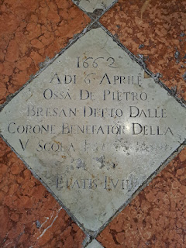

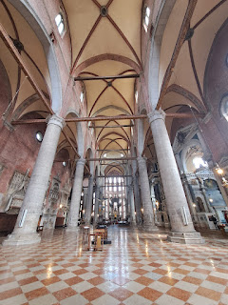

Here is a little bit about the church itself . . .

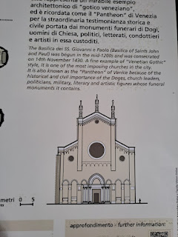

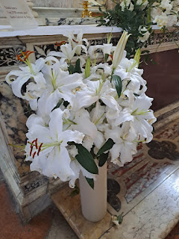

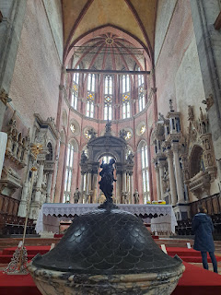

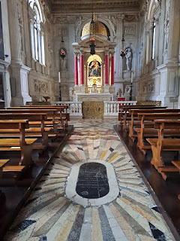

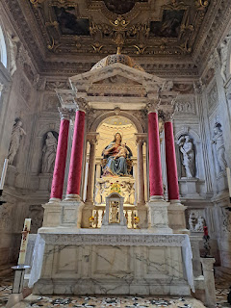

Jack woke up . . . his nap lasted maybe 45 minutes?

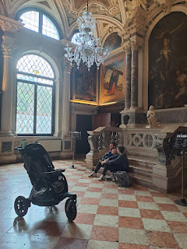

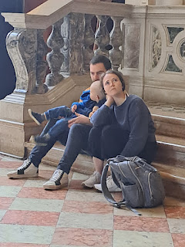

Video of Jake and Hannah working to put Jack's shoes back on so he could walk around a little bit before it was time to get back into the stroller again: (18 seconds)

https://photos.app.goo.gl/LwzD1w6oZLh5XQyX8

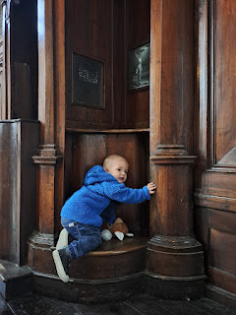

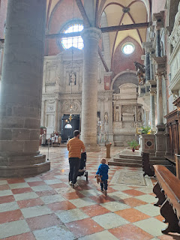

Near the exit of the church, Jack was not happy at all to go back into the stroller. But it was necessary, because we only had a little bit of time left to get back to the train station. We hustled through a few more narrow alleyways to get to the McDonald's of Venice, ha ha. Jack was about to get a happy meal!! :)

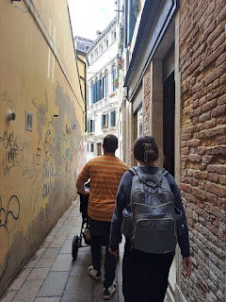

The many faces of Jack as he waited patiently for his chicken nuggets and fries.

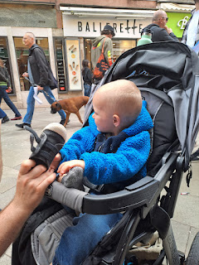

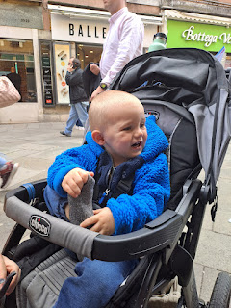

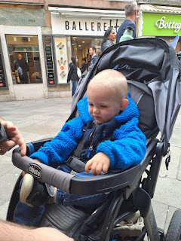

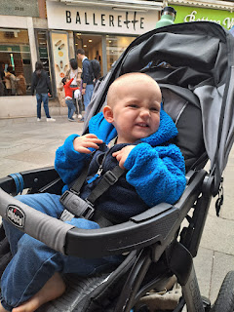

Video of Jack while he waited: (25 seconds)

https://photos.app.goo.gl/pcMDGzUvaipoV1z6A

This large bridge is the same one we walked across upon arrival earlier that morning. We passed it one final time as we approached the train station.

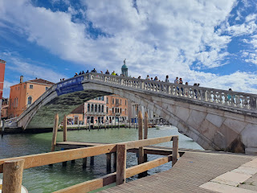

We got on board early, since the train was already sitting there. There was a spot for Jack in the bike rack area, so he just hung out there for a little while as people continued to board. We were sitting across the aisle from him.

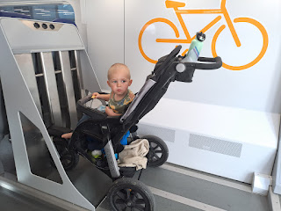

Video #1 of Jack, at the end of a very long day: (34 seconds)

https://photos.app.goo.gl/RU6t4UUMsMk64L6x9

Video #2 of Jack, same comical situation: (32 seconds)

https://photos.app.goo.gl/YDEnhwy4eNr9Scty8

Pretty soon, however, more people arrived with bicycles that needed to go into that same area where Jack currently was. Hannah unbuckled him so we could hold him and then fold the stroller down . . . but that's when she saw the disaster in his stroller . . .

Sometime in those last few minutes, Jack had pooped. A TON. It was all up his back and all over inside the stroller behind where he had been sitting . . . Jacob grabbed Jack's blue jacket from underneath the stroller and wrapped it around Jack's middle to then hold him on his lap. Hannah cleaned up the poop as best as she could with baby wipes. I dumped out the tissues in my purse so we could have a ziploc bag for storing the dirty wipes. And then we rode the 48 minutes back to Vicenza. LOL

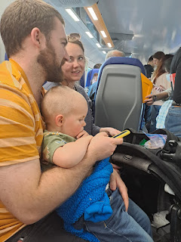

Once we got off the train, and before we boarded the bus back to our neighborhood, we found a grassy spot at the park across the street where they could lay him down and get him all cleaned up. What a relief, ha ha. When we got home, he had a nice bath and got all freshened up.

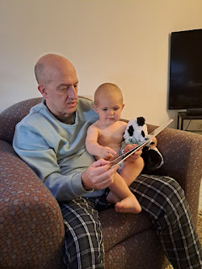

Such is life with a two year old while visiting a popular and romantic city such as Venice. :)

Thursday, May 4th:

Back at it again, but we stayed much closer to home this time. We rode the bus to downtown Vicenza so we could visit the Farmer's Market.

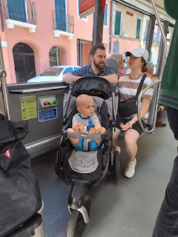

Video of a street performer with his flute: (10 seconds)

https://photos.app.goo.gl/FzKfUNCPiQ2zTeSV7

Video of a Mime: (10 seconds)

https://photos.app.goo.gl/gLCRfHXQrddz2VbR9

This booth was the same one where the two old guys were packing up and helping each other the previous week. This time, I bought two medium length salad forks made from olive wood. They were 5 euros each. :)

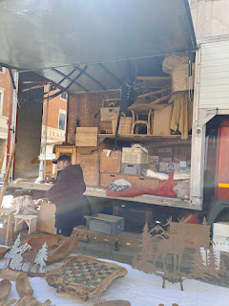

Jacob was hoping to find some clothes in Italy, but he still didn't find what he was looking for.

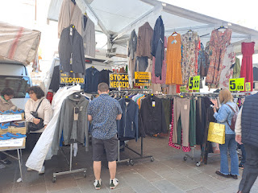

I bought some purple and green hydrangeas, which made me happy. We also ran into Jon Carlo again, and he was so happy to see us! He remembered Jack's name, too. We passed some food trucks, where I bought some pasticcio to take home for lunch. Pasticcio is pronounced "pass-TEE-chee-oh" and it means "messy lasagna". It is SO GOOD!!

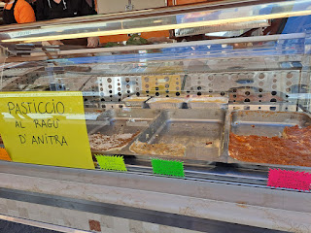

Jacob waited patiently for his turn to buy some handmade local sausage with garlic in it. At the food trucks, you take a numbered ticket and just wait for your number to be called. Sometimes you can also see the numbers on a digital sign, too, which helps if you don't know what they're saying in Italian.

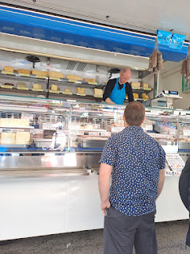

After Jack's nap, we drove up to Treviso to see Avery and Kylie.  It's a great meeting spot halfway between Vicenza and Aviano, and I found a great park and playground there for the little ones (using Google). It's called "Playground Primo Sport 0246."

Jack and Avery were finally able to meet for the first time!! It was so adorable.

Scott is holding Avery, and Jake is holding Jack

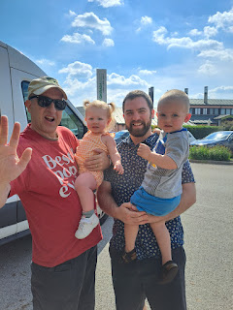

Avery was so sweet - at one point she reached out for Hannah to hold her and then went right to her.

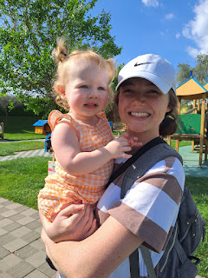

Avery enjoyed a brief stint in the swing . . .

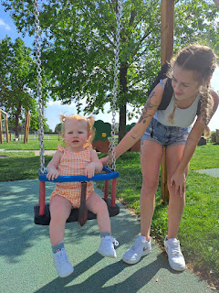

I love this photo so much - the two cousins are eyeing each other from their swings . . . XOXO

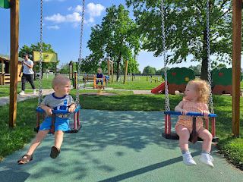

Avery enjoyed letting her Uncle Jake hold her for a while . . . what a sweet moment.

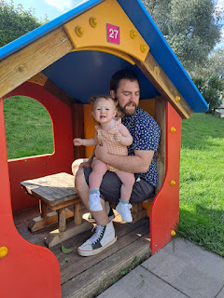

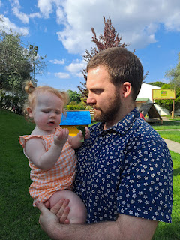

Meanwhile, Hannah was taking her turn chasing Jack around. He was full-speed-ahead and was having a BLAST!!

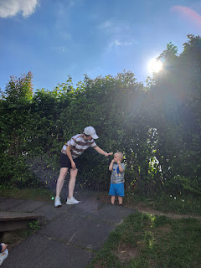

Those two first cousins have two very different personalities. Avery is very quiet and chill for the most part, even though she can be silly and loud sometimes. Jack is a goof-ball and full of energy and is very capable of doing big-kid fun at the park.

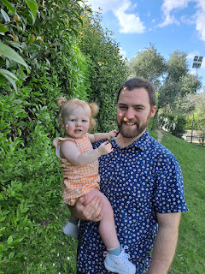

Kylie and Avery - XOXO

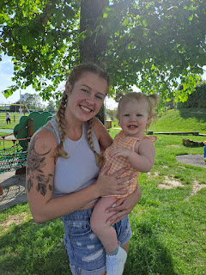

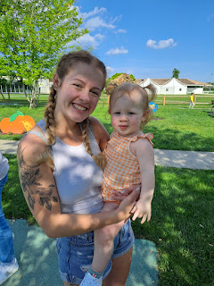

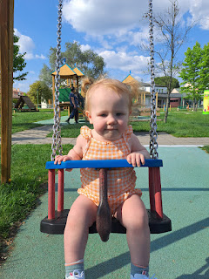

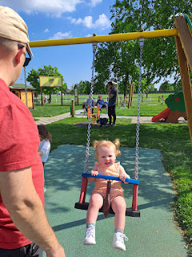

Kylie worked patiently for several minutes to convince Avery to crawl through the tunnel to her.

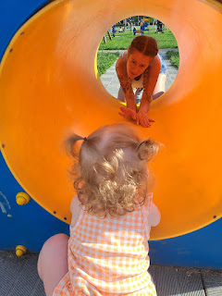

She would crawl partway, and then scoot backwards again . . .

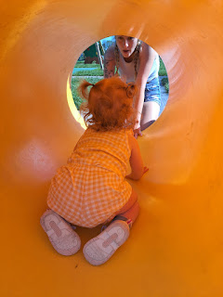

But she was very content to just sit there and watch the other children running around nearby.

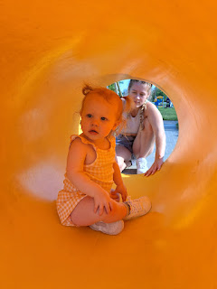

Here is a series of extremely glamorous photos of me as I tried to make a choo-choo-train of grandchildren to go down the slide together. Enjoy!

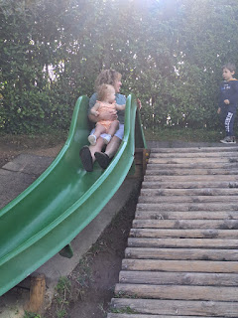

Trying to lift Jack up and over Avery and me . . .

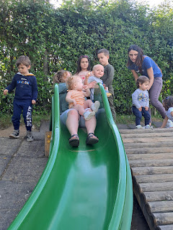

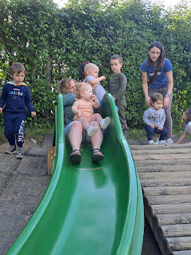

To then be the brave boy in the front . . .

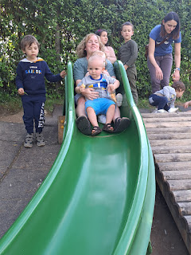

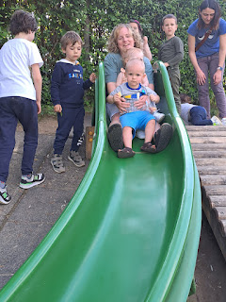

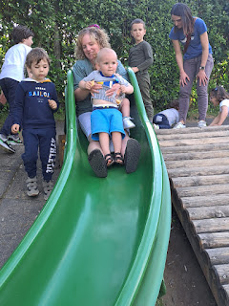

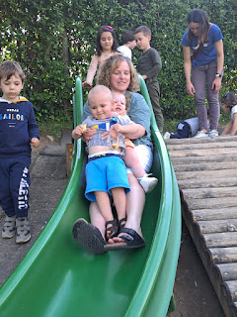

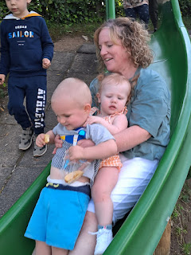

Jack was happy as a clam, while Avery wasn't too sure about the whole thing . . .

Video of Jack deciding whether or not to roll down the hill like the big kids: (28 seconds)

https://photos.app.goo.gl/B6x9Pf2AdUQKaGh1A

Video of Jack's version of "rolling down" the hill: (36 seconds)

https://photos.app.goo.gl/ffjVRWnGWjRYMSLeA

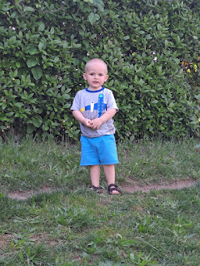

Avery had a big fear of grass. She was completely immobilized at one point in the park, crying because she wanted her momma, who was maybe 1-2 steps away, but it meant she had to step from one paver stone to the next with a tiny amount of grass growing up in between.

Near the end of our visit in the park, I helped teach Avery that being in the grass is okay.

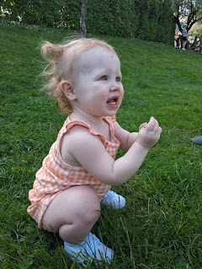

First, I just held her in my arms and showed her how I could move my foot around in the grass. Then I crouched down low with her, and "petted" the grass, moving my fingers back and forth through the blades and other weeds. Next, I picked a clover stem and let her hold it, followed by me handing her a flowering weed, and then a couple blades of grass. Eventually, I could set her down and let her do her own exploring. She didn't cry once. :)

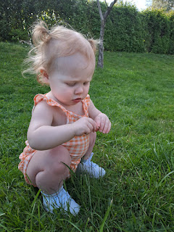

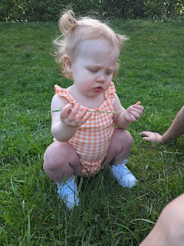

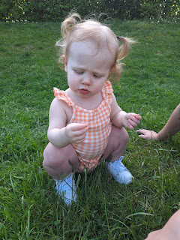

Video of Avery enjoying the grass: (25 seconds)

https://photos.app.goo.gl/cQXpicM7hrwW2HT57

Soon, it was time to go. Avery had a pending bedtime (which was a little earlier than Jack), and we still needed to make dinner after our one-hour drive home. We had a wonderful time, though, and I'm so happy that the cousins could meet!!

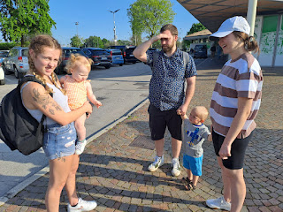

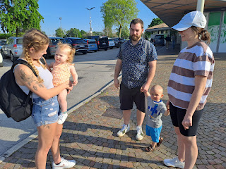

Once we got home, I arranged the flowers that I had bought at the farmer's market that morning, and Jacob cooked up some tasty shrimp and pan-seared zucchini. It was delicious!

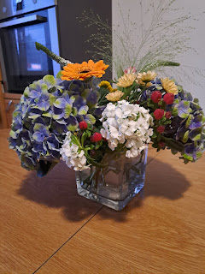

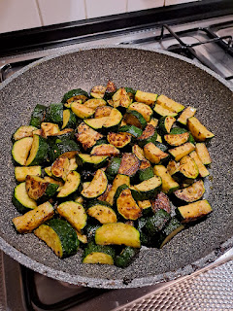

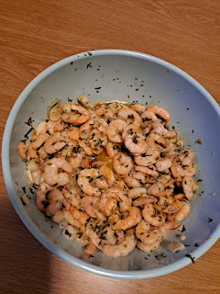

Friday, May 5th:

We headed out early (by 9:20 a.m.) to go to Padova. We decided to drive ourselves this time, instead of using public transportation. It saved us a little bit of stress from having to keep up with their specific timelines.

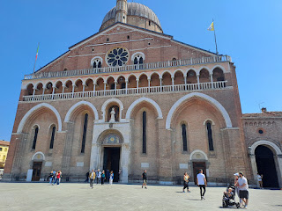

This is the Basilica of St. Anthony in Padova. St. Anthony is the patron saint of Padova, and they revere him greatly. Inside the Basilica, you are technically not allowed to take photos, but a few people still did. (Including me . . . nervous laugh) In the photo above, Jake, Hannah, and Jack are on the far right.

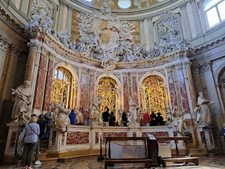

I snuck in a picture at this point because I wanted to capture Jack's wonderment as the two of us sat off to the side. Jake and Hannah were looking at all the intricate items in the glass cases (photo above) that related to St. Anthony, including his vocal chords, teeth, tongue, etc. He was known as being an eloquent preacher of Christianity, bringing many to Christ long ago, and the Italian people chose to preserve those parts of St. Anthony so they could stay connected to him all these centuries later.

To keep Jack happy while we waited, I pointed out all the "babies" on the ceiling and around the room. The cherub angels truly looked like babies to him, and he enjoyed finding more and more to point out.

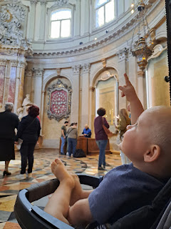

As we left that interesting room and began to walk through the last section of the cathedral, a priest noticed us, due to Jack's distressed mood (because he was stuck in a stroller). He came over and started speaking in Italian, but quickly changed to English once he realized we didn't understand. He was trying to distract Jack from his sadness by pointing out various features up high that could be counted, "Uno, due, tre", etc. He was very sweet. I asked him if it would be okay to take a photo, and he only hesitated for a moment before saying yes. :)

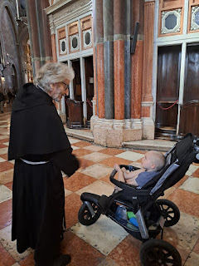

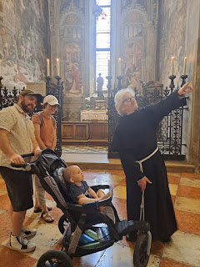

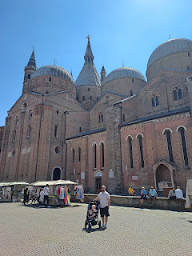

Once we left the Basilica, we walked a few blocks to get some lunch. We chose the same place that I went with my Benvenuti Class back in November, because it was close, they are super friendly, and the food is delicious. It is called: Ristorante Vecchia Padova.

Jack was very happy once he was eating some tomatoes. They have to watch him sometimes, because he will eat too many if left unattended . . .

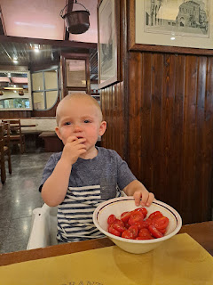

We had an assortment of meatballs, polenta, fish, fries, and pasticcio. Fantastic!

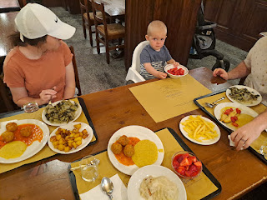

After lunch, we walked around some more, with the goal to take a peek at the Padova University and to see the Prato della Valle.

This sign explains a little bit of the history of the neighborhood we were in, including an ancient tower and a nearby butcher house. (click photo to enlarge)

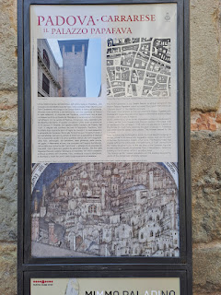

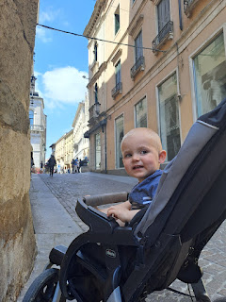

Jack was able to pet this fluffy dog, which made him smile. The owner spoke some English and briefly stopped to chat with us as he walked by.

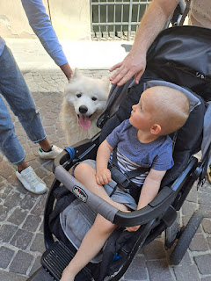

This next sign gives some explanation about the University of Padova, including some of the notable teachers during the 1300's and what they were known for. (click on photo to enlarge)

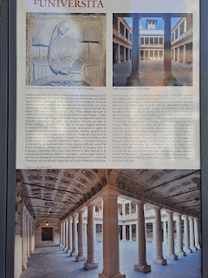

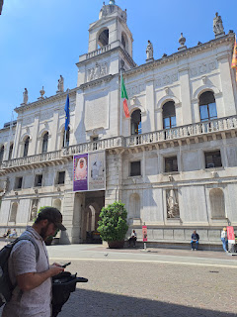

Inside the inner courtyard of the University, there was a beautiful "artsy" wall, with this old reclaimed wood. On the ground in front of the wall was a series of explanations of how it all came to be. (I thought I got all of the explanations, but I think I may have missed one . . . sorry!)

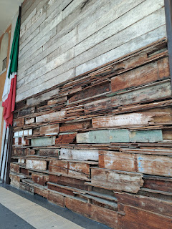

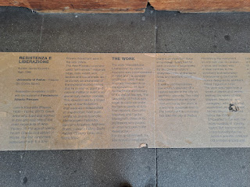

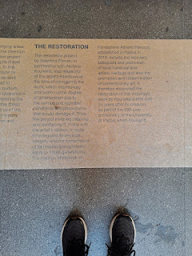

Continuing our walk south . . .

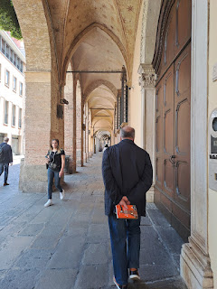

We eventually arrived at the Prato della Valle, where my Benvenuti class visited last November as well. This is the largest public square in Italy, and one of the largest in Europe (90,000 square meters) . It consists of a large oval shape with grassy areas and seating in the middle, surrounded by a canal that is flanked on both sides with statues of influential people who had ties to Padova.

Jacob and Jack

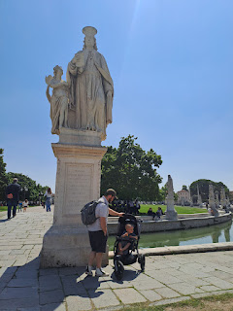

It's such a small world when you run into the missionaries just about anywhere . . . this set of young men were so friendly and fun. This young elder (missionary) was from Rome but spoke excellent English with us. I asked him how he learned how to speak English so well, and he said that during Covid-19 in 2020, he used YouTube as a tool to learn the language and to pass the time that year. Amazing!

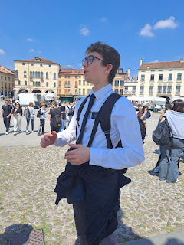

His companion went a short ways off to talk to someone, but he visited with us briefly first and told us he was from Richfield, Utah.

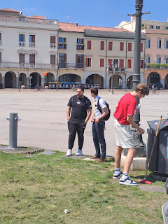

We walked around more than half of the entire loop.

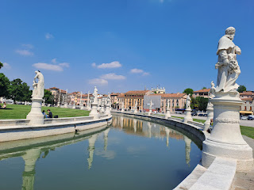

Jacob, Hannah, and Jack (who was getting a little sleepy at this point) . . .

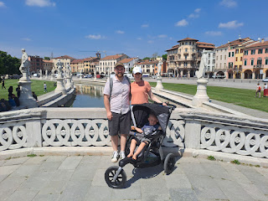

Galileo Galilei

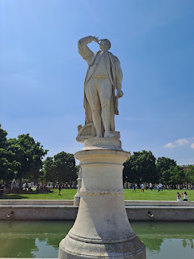

We got a kick out of Jack because he had been holding these same Ritz crackers for about 45 minutes, and eventually fell asleep with them still in his grasp . . . what a cutie.

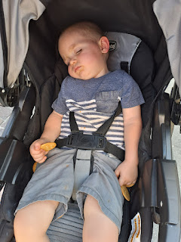

We made it back to our car soon after, and drove back to Vicenza. Jack got a little more of a nap in the car, which was nice, but when we got home, he was ready to play again! Sometimes, his version of play looks more like work . . . ha ha

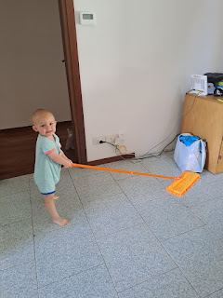

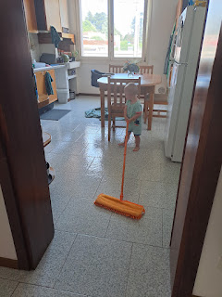

Video of Jack the Butler: (29 seconds)

https://photos.app.goo.gl/GdUjmQzfFhmPmoqG9

We had a Ward Party that evening on the base. There is a playground behind the Ederle Inn, and the best part about it is that it's gated, so there won't be any little escapees. We made a large bowl of homemade salsa and brought some chips to go with it. The Elders Quorum cooked up some hamburgers and hot dogs as the main dish, while many others brought side dishes to share.

It was fun for our visiting family to meet some of our good friends from church and vice versa. Jack had a blast playing nonstop the entire time.

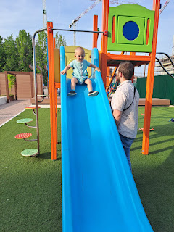

This sweet little girl is Rosie and she is the same age as Jack. Her parents loaned us the pack & play for Jack to sleep in, as well as a nice assortment of toys to add to my meager supply.

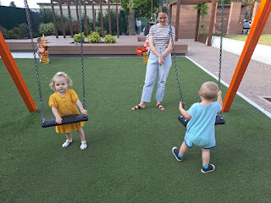

Saturday, May 6th:

We visited Querino Park again (the Bunny Park), but this time we brought sliced carrots with us to distribute. Jack wanted to drive us there, but, . . . um . . . you kinda need to wait a few years . . .

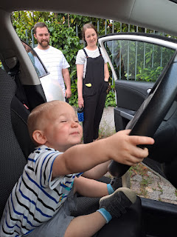

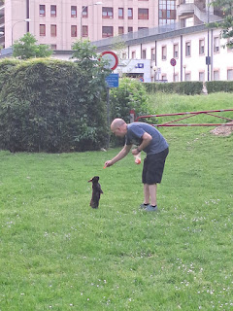

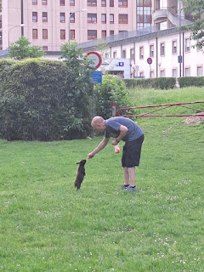

Video #1 of Scott feeding a black bunny with Jack: (10 seconds)

https://photos.app.goo.gl/DkV1UCn9UWNKEUNb6

Video #2 of Jake feeding a bunny: (9 seconds)

https://photos.app.goo.gl/5B12DY8joxviiTya7

Video #3 of Jack hanging out with the bunnies and eating the carrots that we had given him to feed them with: (13 seconds)

https://photos.app.goo.gl/cJDoD6rcZfLvLRzj7

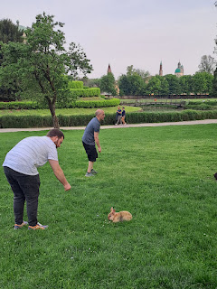

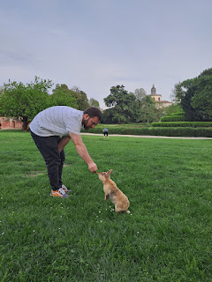

Jack enjoyed rounding up handfuls of gravel and transplanting them into the trunk of this misshapen tree. This made him VERY happy.

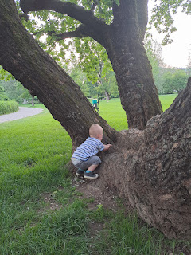

We fed and fed and fed the bunnies all over the park until all of our carrots were gone.

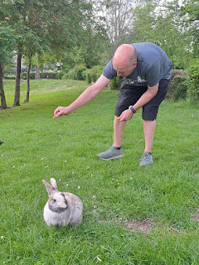

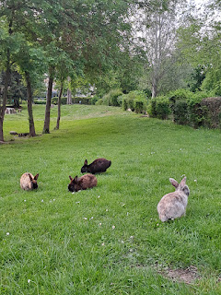

More bunny videos - -

Jacob feeding a bunny: (11 seconds)

https://photos.app.goo.gl/CzafiwgqDKn7qCHn8

Scott trying to get close to a whole different type of bunny: (18 seconds)

https://photos.app.goo.gl/7ba3FMpbZgLuwRq69

This is what he (or she) looked like up close . . .

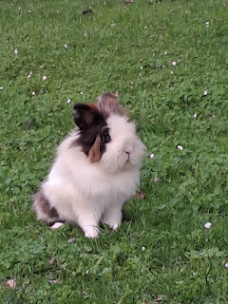

Jack enjoyed the good ol' Toss-the-Baby game: (11 seconds)

https://photos.app.goo.gl/BY7fL78gbAmkY2zF9

More Toss-the-Baby: (24 seconds)

https://photos.app.goo.gl/KJdkFHWVyc1zLce66

When we got home, Jack was in his happy place holding hands with Dad and Bappa, counting all the steps going up.

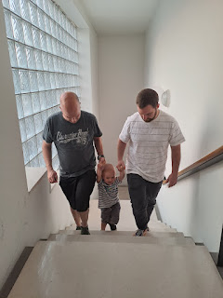

On this same day, back in California, my dad turned 75 years old!! Happy Birthday Pops!! Love you so much. He had a little grouping of family in the area that came to celebrate with him.

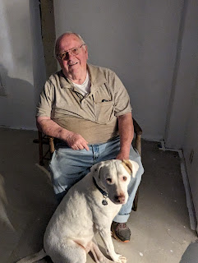

Sunday, May 7th:

After church, we made some dinner to take up north to share with Benson. We cooked up some marinated salmon, rice, green and white asparagus, and watermelon. Jake and Hannah had baked some homemade oatmeal chocolate chip cookies the night before, so we brought some of those with us, too.

As we got close to Aviano, there was a huge field with blooming red poppies, with the Dolomites in the background. It was so beautiful. Even though we knew that Mom (Coy) was in her final days and hours back in Idaho, we were seeing her favorite red poppies everywhere in Italy and it reminded us of her. It helped us still feel connected to her when we were so far away.

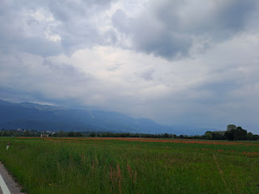

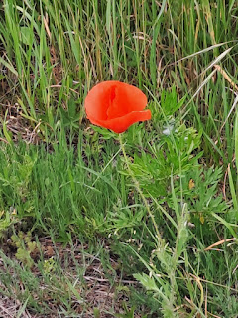

Jake and Benson got to hug each other for the first time in almost 2 years . . .

Video: (14 seconds)

https://photos.app.goo.gl/yEn1d9ZffcbLQiZ8A

Benson also got to meet Jack for the first time ever. :)

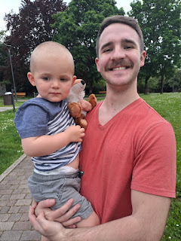

Baby swap, ha ha . . . Benson with Jack and Jake with Avery

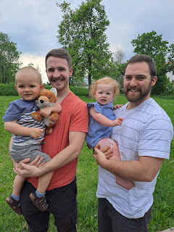

Back at Benson's house, he showed us a very handsome saber that his unit gave him as a gift for his 4 years of  service in Aviano.

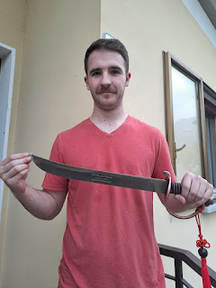

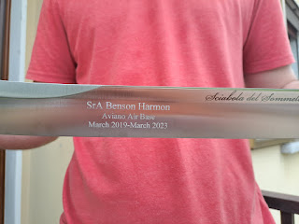

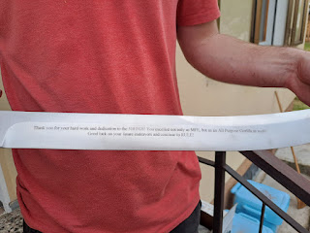

We took our dinner out to the back yard to enjoy the fresh air.

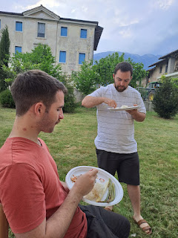

At first, Avery was very shy and didn't want to try the salmon.

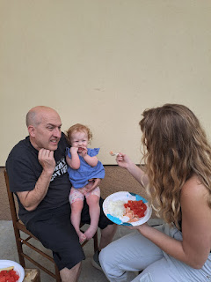

But once they got a bite into her mouth, she couldn't get enough of it after that . . . ha ha

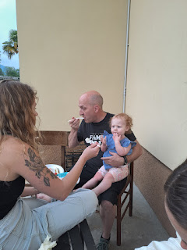

Benson's landlord was working next door, hauling wood and stacking it with her husband. They drove past the house many times on their big tractor, which made Jack infinitely happy. She thoughtfully paused her work for a minute or two so that we could get some group photos in the back yard.

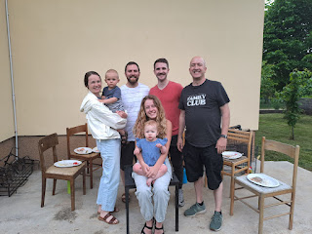

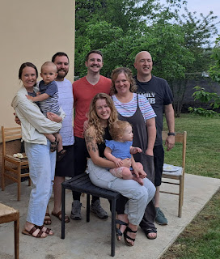

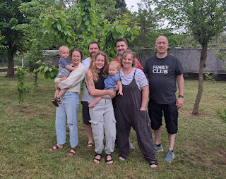

Avery was very subdued that afternoon. She had a rash from head to toe, some sort of allergic reaction to who knows what, and so she didn't have as many smiles to share. Poor sweet girl.

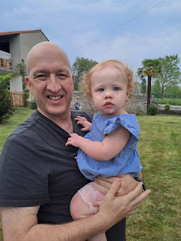

Jacob was so sweet with her, scooping her up and taking her over to see some white roses in bloom near the edge of the yard.

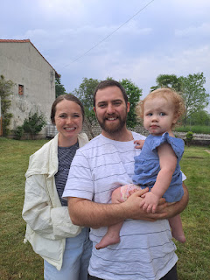

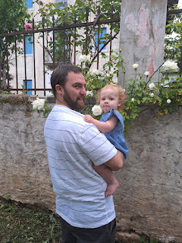

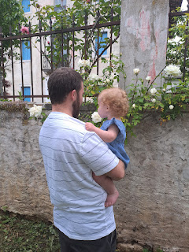

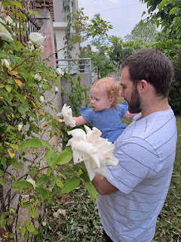

Jack and Bappa . . .

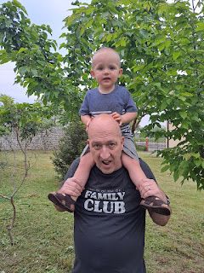

A few more group photos before we left . . .

Benson, Me, and Jacob

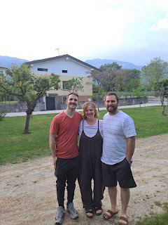

Scott, Benson, and Jacob . . .

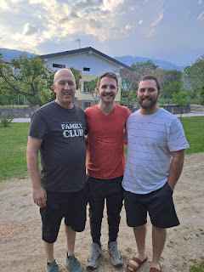

Da Boys . . .

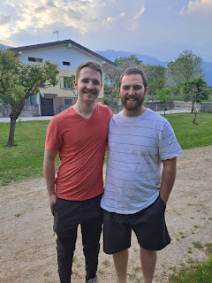

Last look at Benson's house that he's been in for over 3 years . . .

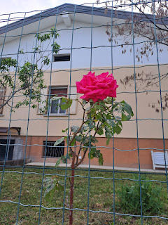

Meanwhile, back in Idaho, Amber was holding Grandma's hand and offering her love, her peace, and her comfort.

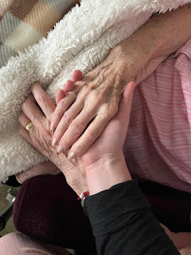

The Primary children had also come to sing to Coy on the front lawn around this same time. What a precious day that was on the other side of the world, with so many family members gathered in her honor, to hold her hand, sing to her, pray for her, and just be near to her.

The whole time we were eating dinner with Benson, Kylie and Avery, I kept thinking that we were having a little family reunion in Italy, while Mom was preparing to have a joyous reunion in heaven at any time. Reunions are a beautiful thing. Family is precious. Family means everything. Heavenly Father blessed us with a mom and a dad, and in many cases, siblings, to be a support and a safety net when things get tough in the world out there. We are human and therefore have many faults, but when push comes to shove, family is there. Some of the things that matter most to me are hugs, kindness, a listening ear, and quality time spent together. I'm sure that's what God had in mind when He created families.